**2025**

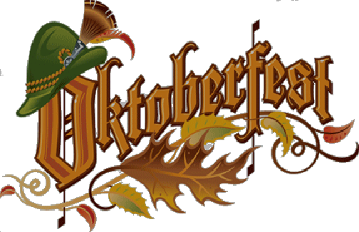

**McAlester**

**Guten Tag!**

Join us as we celebrate our community's German history. We are excited to announce our 3rd annual *McAlester Oktoberfest* will be held Friday and Saturday, October 24th and 25th at the Southeast Expo Center west of McAlester.

Your sponsorship will help us provide a fun, festive atmosphere. Visitors will experience Biergartens and Wine Gardens, hear German music from our bands, see traditionally dressed dancers, participate in fun German games and contests, taste traditional offerings at our German Café, and shop a variety of merchandise and food vendors. Many other activities are being jam-packed into our festival, including kids’ activities, Mud Bog races, Hot Air Balloon and Helicopter rides, various static displays, a sanctioned Corn Hole tournament, a juried Fine Art Show, and many more activities, all either inside the Expo or on the festival grounds. Whew! That’s a lot of stuff!

You can help us achieve our budget goal by being a sponsor! We are working hard to make this year’s festival even bigger and better than before. We’ve broadened our marketing plan and increased our advertising budget to extend our reach. Our goal is to make McAlester Oktoberfest an anticipated, annual, signature event for McAlester and one that is recognized throughout the state. As a signature festival, it will attract participants and visitors from all over Oklahoma and surrounding states, which will greatly benefit our entire community.

Here are some sponsor benefits: (see additional benefit listing under each level)

* **You will be offered a free Vendor space (a $100 value).**
* **You will help to keep the festival free for attendees.**
* **You will contribute to McAlester’s maintenance, progress, and sustainability.**
* **You will help make McAlester’s Oktoberfest one of southeast Oklahoma’s largest and most popular festivals.**

We invite you to join other local businesses in generously promoting this festival as a sponsor. A form is enclosed on which you can indicate your level of support.

**Thank you for your sponsorship of McAlester Oktoberfest 2025!**

Dennis Wilson, President

McAlester Oktoberfest Committee

Event Coordinator

**2025 McAlester Oktoberfest Sponsorships**

**FESTIVAL SPONSORS– Friday & Saturday, October 24TH & 25TH, 2025**

**$1,000 PLATINUM FESTIVAL SPONSORSHIP**

Extensively promoted through advertisement as a **Platinum-level** Sponsor

Prominent Business logo printed on festival Advertisements and the Festival’s Website Main Page

Prominent placement on the Festival’s Sponsors Banner

Recognition from the Main Stage throughout the Festival

**$750 GOLD SPONSORSHIP MAIN STAGE ENTERTAINMENT (Entertainment TBD)**

Promotion through advertisement as a **Gold-level** Sponsor

Business logo/name on Festival Advertisements and the Festival's Website Sponsor Page

Business Logo/Name on Festival’s Sponsors Banner

**$500 SILVER SPONSORSHIP - Biergarten or Wine Garden (*Specify below)**

Promotion through advertisements as a **Silver**-level Sponsor

Business logo/Name on Festival Sponsors Banner and Website Sponsor Page

Business logo/Name on Signage in Bier Garten or Wine Garden (High traffic area)

**$250 BRONZE SPONSORSHIP – Stein Hoist, Keg Roll Contest, German Costume Contest (Specify below)**

Promotion through advertisement as a **Bronze**-level Sponsor

Business logo/name on Festival Sponsor Banner and Festival’s Website Sponsor Page

Business logo/name listed in the German Contest area and mentioned during the Contest

**$100 FRIENDS OF THE FESTIVAL SPONSORSHIP**

Business logo/name listed on Festival’s Website Sponsor Page

Business logo/name on the festival Banner

Company Name__________________________________ Contact_____________________

Address_____________________________ City_______________ ST_____ Zip__________

Phone____________________ Email_____________________________

We would like the following sponsor level: ______________ **Deadline for logo receipt is Sept 19, 2025**

*Bier Garden, Wine Garden or Contest Choice: ______________________ Amount enclosed:$_______­­­­­­­­­_

.

**Checks payable to “*McAlester Oktoberfest”***

***Or pay via our website: https://www.mcalesteroktoberfest.com***

**Mail to c/o Dennis Wilson, 412 Hass Rd, McAlester, OK 74501**

**Questions? Please call/text Dennis Wilson @ 918-916-6165**

**Email logo to: mcalesteroktoberfest@yahoo.com**

**2025**