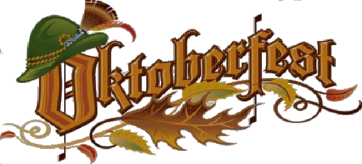

**McAlester** **2025**

**FRIDAY & SATURDAY, October 24th & 25th, 2025**

**MCALESTER OKTOBERFEST MAJOR CORPORATE SPONSORS**

All Major Sponsor levels will receive maximized exposure through our televised commercial ads on **KJRH Channel 2**, which include: **96** TV :30 commercials that will air 3 weeks before McAlester Oktoberfest, **10** :15 Noon News Giveaway promos (weeks of 10/6 and 10/13). Ads will be seen on Streaming TV through 150+ networks targeting special interests in the areas of Durant, Sherman/Denison, Fort Smith, Broken Bow, Tulsa and OKC, Digital Out-of-Home video ads targeted in places such as Bars, Restaurants, Gas Stations and College Campuses, All commercials will be streamed live on HULU+ Live, You Tube TV, Sling, Fubo, Peacock, NBC App, Direct TV Stream, **KJRH.com** and apps. , a **KJRH** Facebook & Instagram post (220,000+ followers) and a KJRH Email Blast (11,000 subscribers), plus a free 10 x 10 vendor booth at the festival if desired.

**$10,000 DIAMOND FESTIVAL SPONSORSHIP**

**Advertisement**

Extensively promoted through advertisements as a major sponsor at the **Diamond** level, primr 1st Level placement of Business Logo on the festival website Home page and Sponsor pages, all printed advertisements, Sponsor's Banner, acknowledgement on festival social media pages, mention in Radio ads, major recognition from the Main Stage throughout the festival, and an opportunity to address the audience. If desired.

**$5,000 RUBY FESTIVAL SPONSORSHIP**

**Advertisement**

Extensively promoted through advertisements as a major sponsor at the **Ruby** level, a large 2nd tier level placement of Business Logo on the festival website Home page and Sponsor pages, all printed advertisements, Sponsor's Banner, acknowledgement on festival social media pages, mention in Radio ads, multiple recognitions from the Main Stage throughout the festival

**$3,000 SAPPHIRE FESTIVAL SPONSORSHIP**

**Advertisement**

Extensively promoted through advertisements as a major sponsor at the **Sapphire** level, a large 3rd tier level placement of Business Logo on the festival website Home page and Sponsor pages, all printed advertisements, Sponsor's Banner, acknowledgement on festival social media pages, mention in Radio ads, several recognitions from the Main Stage throughout the festival.

**Company Name__________________________________ Contact_______________________________**

**Address_____________________________ City_______________ ST_____ Zip__________**

**Phone____________________ Email_____________________________ I would like a 10 x 10 booth ______ (Y or N)**

**We would like the following Major Corporate Sponsor level: _____________ Amount enclosed: $__________**



**Checks payable to “*McAlester Oktoberfest”***

***Or pay via our website: https://www.mcalesteroktoberfest.com***

**Mail to c/o Dennis Wilson, 412 Hass Rd, McAlester, OK 74501**

**Questions? Please call/text Dennis Wilson @ 918-916-6165**

**Email logo to:** [**mcalesteroktoberfest@yahoo.com**](mailto:mcalesteroktoberfest@yahoo.com) **by 9/19/25**

**2025**